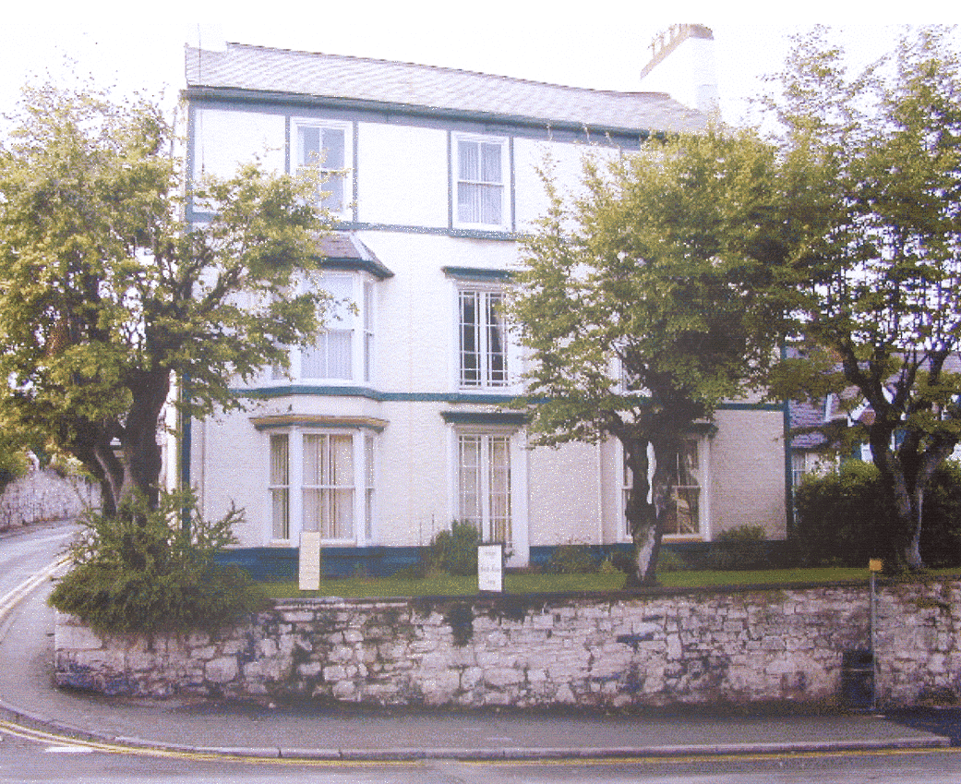

**Beech House Surgery**

Educating and training students to become excellent clinicians,

scientists, teachers, and innovators.

|  |  |
| --- | --- |
| 69 Vale Street  Denbigh  Denbighshire  LL16 3AY  Tel: 01745 812863  Fax: 01745 816574 | The Health Centre  The Roe  St Asaph  LL17 0LU  Tel: 01745 582251  Fax: 01745 583495 |

Beech House Dispensary: 01745 813689

email: enquiries.w91033@wales.nhs.uk

**www.beechhouse.gpsurgery.net**

**Practice Profile**

Beech House Surgery was established in 1850 and is located in the market town of Denbigh. The surgery has a wide rural catchment area and is a dispensing practice. There is a branch surgery in the small cathedral city of St Asaph, six miles north of Denbigh.

We have a patient list size of over 9,200 patients, which is supported by a skilled, approachable health care team consisting of six GP Partners, GP Registrars, Nurses, Assistant Practitioner, Reception, Dispensary, Administrative staff, Health Visitors, and Midwives. A team approach is taken in the management of the Practice and the healthcare of its patients. Regular Practice and Clinical Governance meetings, led by one of the Partners and made up of representatives from each discipline, leads Practice development and clinical care.

The Practice ethos is one of continuous improvement and it supports training. Regular staff training is undertaken in-house, as well as attending external courses. The Practice accepts medical students from Cardiff and Liverpool Universities, as well as other medical schools and supports students who have an interest in perusing a career in medicine.

Both surgeries are fully computerised using the Emis Web clinical system. We are now virtually a paperless Practice, with all test results and many hospital letters received electronically.

We undertake minor surgery and joint injections within the Practice. We offer travel advice and vaccinations. The Practice nurses also provide a full range of services including health promotion and chronic disease management. Community nurses visit the surgeries daily and play a full role within the Primary Care Team. Health Visitors are based in Denbigh Infirmary and St Asaph Surgery.

Ysbyty Glan Clwyd in Bodelwyddan, located approximately eight miles away, is the nearest acute District General Hospital and provides all the services for the area, whilst Denbigh Infirmary offers convalescent respite and terminal nursing care for the patients of Denbigh GPs, together with a minor injury unit and phlebotomy suite.

An out-of-hours service covering for the Practice is provided by NHS 111 Wales from 6:30 pm to 8:00 am weekdays, during the weekend, and Bank Holidays. Tel: 111. Advice can also be obtained by calling NHS Direct on 111 or via the website https://111.wales.nhs.uk/

**The Primary Health Care Team**

**The Doctors (GP Partners)**

The Partners hold a joint list and patients have the right to express a preference of who they would like to see, subject to availability of appointments. Please make your preference known to the reception team when making an appointment.

* **Dr Peter Romachney** MB ChB (Manchester 1991) DRCOG, MRCGP. GP Registrar

Trainer. Dr Romachney joined the Practice in 1997.

* **Dr Abdul Pasha** MBBS, MRCGP, DFSRH, Dip CTG (Mysore, India 2001)
* **Dr Nicky Davies** MB ChB (Sheffield 1997) MRCGP, DRCOG, DFSRH. Dr Davies joined the Practice in 2009 and became a partner in July 2012.
* **Dr Jonathan Edwards** MB ChB, MRCGP (Cardiff 2005). Dr Edwards joined the Practice in September 2013.
* **Dr Naval Bilolikar** MBBS, MRCGP, MS Orthopaedics. Dr Bilolikar joined the Practice in March 2012 and became a partner in November 2014.
* **Dr Hayley Scott** MB ChB 2010 University of Birmingham. Dr Scott joined the Practice as a Partner in September 2019.

**Practice Management**

* **Lesley Alexandrou, Practice Manager** (Joined the Practice in 2001).
* **Stephaine Conway-Williams (J**oined the practice in 2018)

are responsible for the day-to-day management of the Practice and can be contacted on 01745 812863.

**The Nursing Team**

* **Andrew Williams ANP** joined the surgery in July 2019. Andrew is an Advanced Nurse Practitioner and works closely with the GPs. Andrew possesses many years’ experience in the field of orthopaedics.
* **Delyth Evans RGN** joined the Practice in January 2019.

Delyth is our Minor Illness Nurse and will see a wide range of Minor Illnesses.

* **Andrew Jones, RNA/SPDN** joined the Practice in August 2017 and has an interest in respiratory and diabetes conditions.
* **Lyn Bellis RN** joined the Practice in March 2021.
* **Lyn Jones, Assistant Practitioner** joined the Practice in September 2002. She is a trained phlebotomist and assists in a wide variety of other nursing duties e.g. spirometry, CHD, flu and Covid vaccinations.

**The Receptionists**: Receptionists provide an important link for patients of the Practice and are your initial contact point for appointments and general enquiries. They also provide basic information on services and results and direct you to the right person depending on your health issue or query.

**The Dispensers**: The team are able to dispense your medication within the surgery if you live over one mile away in a straight line from a chemist. Repeat prescriptions can be ordered by:

* + Participating in the surgery’s automatic reordering system (dispensing patients)
  + Leaving a request slip in the post box
  + Using our online service, NHS Wales APP

Please allow 72 hours (3 working days) for collection. Please note requests placed on a Friday afternoon will not be ready for collection until the following Wednesday afternoon, adding one or two days if over a Bank Holiday. (If attending an appointment with the doctor please allow 72 hours for your repeat prescriptions).

* We offer a Home Delivery Service to our housebound or infirm dispensing patients. Please ask a member of dispensary staff for details about this service.
* The local chemists collect prescriptions for our non-dispensing patients on a daily basis, allowing you to go direct to the chemist 72 hours from ordering for collection. Please ask a member of dispensary staff to set this up should this be of advantage to you.

**The Practice Nurses:** The Practice Nurses are highly skilled and experienced members of the team, who hold a variety of clinics and can advise on a range of health topics. All nurses cover the following duties:

* ECGs
* Health checks – including smoking cessation advice and dietary advice
* Well-person and cholesterol advice
* New patient health checks
* Over 75 health checks
* Phlebotomy
* Suture removal
* Wound dressings
* 24-hour ambulatory BP monitoring
* TENS machines

**Other more specialised duties include:**

* Asthma
* Diabetes
* Chronic heart disease
* Family planning service
* Hypertension
* Travel advice and vaccinations
* Well woman, menopause, and HRT

**The Admin Team:** Based at Beech House, the admin team deal with the day-to-day administration of the Practice and provide patients with a range of information and advice. The admin team are also able to offer information and assistance to patients who are caring for relatives or friends at home.

**The Community Psychiatric Nurse:** Tim Dyffryn Clwyd, referrals are made via your GP.

**The Community Nursing Team:** The District Nurses can be contacted by leaving a message at the surgery or at Denbigh Infirmary. They are here to help patients and their families after hospital discharge or with chronic illness or disabilities.

**The Health Visitors:** Based in Denbigh Infirmary and St Asaph Health Centre, they are here to offer advice on health care topics for mothers and babies and children up to school age.

**Other Practice Based Services:**

* Child health surveillance
* Family planning services, including coil fitting and Nexplanon
* Minor surgery
* Joint injections
* Stress incontinence service
* Community Psychiatric Nurse
* Citizens Advice Bureau

**How to Register**

It is our policy to accept all patients irrespective of patients' age, gender, race, religion, ethnicity, social class, appearance, sexual orientation or medical condition. If you wish to register with the Practice, please contact a member of the reception team. You will be asked to complete registration forms

All newly registered patients are invited to a consultation with the Practice Nurse for a health check. Please contact reception to make an appointment.

The Practice boundary extends from Denbigh up to the A55 in the North; Cyffylliog & Rhewl in the south, Nannerch in the east; and Llansannan in the west. However, to see if your postcode falls within our boundaries, please provide your postcode to the admin team.

**Temporary Residents**

If you wish to see the doctor while you are away from home, you may register with the Practice as a temporary patient.

**Disabilities**

If you suffer from a disability, we offer:-

* Ground floor consultations with GP and nursing team
* Hearing loop
* Patient information in alternative format documents e.g. large print or audio
* Carer’s information
* Carers support group
* We can also provide information on a variety of support groups

**Language and Interpretation Line**

Language and interpretation services are available; please speak to reception if you require this service

**Please help us to help you**

**If you have any other requirements or comments, please let us know**

**Home Visits**

A doctor can visit you at home if you are housebound, or if it is necessary on medical grounds. However, as we are unable to provide the full facilities of a modern general practice in your home, it is more beneficial for you if you can attend the surgery whenever possible. If you think you require a home visit, please telephone the surgery, preferably before 10.30 am. The doctor may telephone you to discuss your request.

**Consulting a Doctor**

You may consult any doctor within the Practice, as the computerised system enables all GPs to access your health records. Please remember, only one patient per appointment, and please let us know if you cannot keep an appointment so that we can offer it to another patient in need.

**Telephone Advice**

If you telephone to speak to a doctor when he is consulting with patients, a receptionist will take a message and ensure this is passed on so they can telephone you back after their clinic has finished. However, if you need to speak to a doctor in an emergency, the receptionist will put you through to the Duty Doctor.

**Test Results**

**It is the responsibility of the patient to ensure that they contact the surgery for the results of any test they have had**.

**Travel Health**

Patients who are planning to travel abroad should request an appointment with a practice nurse as far in advance of their travel date as possible. The Nurse will provide travel advice and identify if any vaccinations are required. The nurse will then book a further appointment for you to come in to have any necessary vaccinations. Some vaccinations may be provided free on the NHS, but others may incur a charge. These vaccines must be paid for in advance.

**Chaperone**

If you feel that you would like a chaperone to accompany you during a consultation, please notify the reception team upon your arrival. However, you can also request a chaperone at any point during your consultation.

**Change of Personal Details**

Please advise reception as soon as possible if you change your name, address, or telephone number. We will need evidence of any changes to your personal details, apart from a change in phone number.

**Carer Support**

Are you looking after a friend or relative who because of disability, illness or the effects of age could not manage in their own home without your help? Beech House Surgery is able to offer you support and information. If you require further information, please contact a member of the administrative team.

**Access to Medical Records**

Under the Data Protection Act (DPA) 1998, patients have the right to apply for access to their health records. Provided that a written application is made by one of the individuals referred to below, the Practice is obliged to comply with a request for access subject to certain exceptions. However, the Practice also has a duty to maintain the confidentiality of patient information and to satisfy itself that the applicant is entitled to have access before releasing information. A patient can give written authorisation for a person (for example a solicitor or relative) to make an application on their behalf. The Practice may withhold access if it is of the view that the patient authorising the access has not understood the meaning of the authorisation.

Requests should be in writing, with a patient signature. Email requests are valid for the purposes of the DPA, however, the Practice will need to be satisfied that the request is made by the data subject or their legal representative only.

**Confidentiality/Caldicott**

All patient information is confidential. However, it is sometimes in the best interest of the patient that personal information is shared with other health care providers, such as hospital consultants, therapists and other health professionals who are also bound by the principles of confidentiality. There may also be occasions when anonymised patient data is collected for National Health statistical analysis. In order to provide data which is not anonymised, your signed consent will be needed. This will allow us to share information with other NHS organisations where this may be in your interest.

All members of the Primary Health Care Team have an obligation to do everything they can to keep your data safe. The Caldicott Principles are designed to help keep patient identifiable information safe and are used when handling all patient identifiable information. If you feel that confidentiality has been breached, please contact the Practice Manager. The Practice places great emphasis on its duty of care to patients.

We are a Research active Practice and work closely with BCUHB and Department and Health and Care Research Wales. This enables us to offer our patients opportunities to take part in clinical research and allows us to contribute to the development of new treatments. All studies are of high quality and are approved by the Local Health Board. As part of this commitment, we contribute anonymised data to the SAIL database.

**Raising Concerns or Complaints**

Our aim is to provide the highest standard of service and care to our patients. However, we realise that occasionally things do not go as smoothly as perhaps we would like, or perhaps you may feel you have not received the service you expected. If this is the case, please do not hesitate to contact Mrs Lesley Alexandrou, Practice Manager to discuss your concerns. A leaflet explaining the Complaints Procedure is available in the Practice or on our website.

**Violent or Abusive Behaviour**

Our practice staff are here to help you. However, we strongly support the NHS Policy on Zero Tolerance. Anyone attending the surgery who abuses the GPs, Staff, or other patients, be it verbally, physically or in any threatening manner whatsoever, will risk removal from the Practice list.

**Suggestions or Comments**

The Practice welcomes feedback and comments. If you wish to make a suggestion or a comment, please speak to a member of the team. We have a feedback and survey section on our website.

**Patient Participation Group**

We are keen to resume our Patient Group. The intention of the group is to discuss and put forward ideas for the Practice’s development and enhancement of services. We would be very interested to hear from you if you feel you could contribute and become part of this group or if you have any suggestions or comments.

**Staff Training**

This Practice, along with other GP Surgeries, participate in monthly staff training sessions supported by the Local Health Board. The training sessions are of great benefit to the Practice and ensure that we can continue to offer a very high standard of care and service to our patients. The surgery is closed from 1:00 pm up to 5.00 pm, whilst the training takes place. Advance notification of the planned training dates is displayed in the surgery.

**GP Training**

The Practice ethos is one of continuous improvement and it supports GP training. Beech House is a Training Practice for GP Registrars, who are qualified doctors, who wish to work in General Practice.

We accept medical students from Cardiff and Liverpool Universities. These students conduct their own clinics and are supervised by a GP Partner.

We also support 6th Form students who have an interest in perusing a career in medicine. They attend the Practice to observe and gain experience. You will be advised if there is going to be a medical student present during your consultation, but it is understandable and appropriate for patients to request to see the doctor or nurse on their own if they prefer.

**Surgery Opening Times**

|  |  |  |
| --- | --- | --- |
| **Beech House**  **Denbigh** | 8:00 am – 6:30 pm weekdays | If you are telephoning the surgery to enquire about test results, please callin the afternoon when our phone lines tend to be quieter. |
| **St Asaph**  **Health Centre** | 8:00 am – 6:00 pm weekdays | The surgery is closed for half day on Thursdays from 1:00 pm. |

**Out of Hours**

This service provides our GP Out of Hours cover for patients from: 6.30 pm until 8.00 am Monday to Friday and weekends from 6.30 pm Friday until 8.00 am Monday, plus all Bank Holidays. If you need to see a doctor during these times, and you live or are staying in the North Wales area, please telephone: **111.** The Out of Hours Treatment Centres are not drop-in or walk-in centres; patients will only be seen by appointment by calling the Out of Hours number.

ours TraH

**Appointment System**

* Telephone lines are open from 8.00 am to 6.30 pm Monday to Friday (01745 812863). There is a heavy demand in the morning, and we continue to be grateful for your understanding. Appointments do fill up quickly and it is not unusual for the reception team to have limited availability for the doctor of your choice.
* **Bookable in advance**

A number of appointments are available for pre-booking. The times available are 8:30 am to 9:30 am and 4:30 to 5:00 pm. These can be booked up to two weeks in advance. It is not possible to make any advance bookings for the day following a Bank Holiday.

* **Same-day appointments**

We offer same day appointments, which become available for booking from 8:00 am each day. However, we cannot guarantee you will see the GP of your choice if their appointments have already been taken.

* **Urgent appointments**

We also have a Duty doctor who offers urgent appointments for patients who need to be seen the same day. This guarantees that patients who need to see a GP will be offered an appointment. This may not be with a GP of your choice.

* **Nurse appointments**

You can book nurses appointments for up to one month in advance. It is preferable for you to give the receptionist an idea of what the appointment is for so they can make the appointment with the correct Nurse or Health Care Assistant and allocate the appropriate amount of time your consultation requires.

* **Attending Appointments**

Please ensure that you keep all appointments made, or otherwise notify the practice at least 24 hours in advance (where possible) if you are unable to attend. This enables us to offer your appointment to another patient and reduces appointment waiting times.

We experience in the region of 160 missed appointments each month, which are appointments that could have been offered to other patients.

Unfortunately, there may be occasions where patients, who frequently fail to attend their appointments, may be asked to register at another practice due to the inappropriate use of our service.

* **Telephone System**

Please note that telephone calls are recorded for quality and training purposes. When telephoning the surgery your call will be taken through an auto attendant service. You will be presented with a few options to ensure your call goes to the correct department for your query/request. The options are also given in Welsh, although this does not mean that you will automatically be put through to a Welsh speaking member of staff. If you do wish to speak in Welsh, please advise a member of the team.

* **Making Appointments**

The receptionists will ask you for a brief description of why your appointment is needed. This is to ensure that you a booked with the appropriate clinician first time.

**DENBIGH INFIRMARY**

**X-RAY OPENING TIMES**

**(by appointment only)**

|  |  |  |
| --- | --- | --- |
| **DAY** | **a.m.** | **p.m.** |
| MONDAY | 8:30 - 12:30 pm | 2:00 - 4:30 pm |
| TUESDAY | 8:30 - 12:30 pm | 2:00 - 4:30 pm |
| WEDNESDAY | 8:30 - 12:30 pm | 2:00 - 4:30 pm |
| THURSDAY | 8:30 - 12:30 pm | 2:00 - 4:30 pm |
| FRIDAY | 8:30 - 12:30 pm | 2:00 - 4:30 pm |

**DENBIGH INFIRMARY**

**BLOOD TESTS (by appointment only)**

**Please telephone 03000 850025, Option 4, between 10 am & 2 pm to make an appointment**

**Please remember- it is your responsibility to telephone the surgery to obtain your results for any tests you have had.**

**Surgery Telephone Numbers**

Reception/ Appointments Beech House 01745 812863

St Asaph 01745 582251

Dispensary Beech House 01745 813689

Secretaries Beech House 01745 815344

Fax Beech House 01745 816574

Fax St Asaph 01745 583495

Health Visitor Denbigh Infirmary 03000 850019

St Asaph 01745 448772

**Useful Telephone Numbers**

North Wales GP Out of Hours 111

NHS 111 Wales 111

Glan Clwyd Hospital 03000 843843

Denbigh Infirmary 03000 850019

Boots Chemist, Denbigh 01745 812860

Rowlands, Denbigh 01745 812602

Royles, Denbigh 01745 812067

City Pharmacy, St Asaph 01745 583200

Caerwys Pharmacy 01352 721020