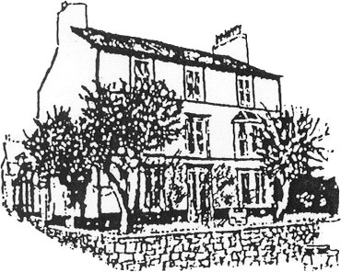

Beech House Surgery

Raising Your Concerns
& Complaints Leaflet

Our aim is to provide the highest level of care
for all our patients.

Raising a concern or making a complaint:  If you have any complaints or concerns about the service that you have received from the doctors or staff working for this practice, please let us know.  We hope that most problems can be sorted out easily and quickly, often at the time they arise and with the person concerned. If your problem cannot be sorted out in this way and you wish to make a complaint, we would like you to let us know as soon as possible – ideally within a matter of days or at most a few weeks – because this will enable us to establish what happened more easily. If it is not possible to do that, please let us have details of your complaint:  - Within 12 months of the incident that caused the problem; or  - Within 12 months of discovering that you have a problem.  Mrs Lesley Alexandrou, The Practice Manager, will be pleased to deal with any complaint. She will explain the procedure to you and make sure that your concerns are dealt with promptly. You can make your complaint:  In person – ask to speak to Mrs Lesley Alexandrou, The Practice Manager  In writing – some complaints may be easier to explain in writing - please give as much information as you can, then send your complaint to the practice for the attention of Mrs Lesley Alexandrou, Practice Manager, as soon as possible  Complaining on behalf of someone else:  Please note that we keep strictly to the rules of medical confidentiality. If you are complaining on behalf of someone else, we have to know that you have his or her permission to do so. A note signed by the person concerned will be needed, unless they are incapable (because of illness) of providing this. |  | What we shall do:  Our complaints procedure is designed to make sure that we settle any complaints as quickly as possible.  We shall acknowledge your complaint within 2 working days and aim to have looked into your complaint within 30 working days of the date when you raised it with us. However, this may take longer if your complaint is complicated.  You shall then be in a position to offer you an explanation, or a meeting with the people involved.  When we look into your complaint, we shall aim to:  - find out what happened and what went wrong  - make it possible for you to discuss the problem with those concerned, if you would like this  - make sure you receive an apology, where appropriate  - identify what we can do to make sure the problem doesn’t happen again.  At the end of the investigation your complaint will be discussed with you in detail, either in person or in writing.  What you can do next:  We hope that, if you have a problem, you will use our practice complaints procedure. We believe that this will give us the best chance of putting right whatever has gone wrong and the opportunity to improve our practice.

If you remain dissatisfied with the responses to your complaint under the first stage, you have the right to ask the Public Services Ombudsman for Wales to review your case or seek advocacy from Community Health Council (see below for addresses).

Public Services Ombudsman For Wales:
1 Ffordd yr Hen Gae,
Pencoed,
CF35 5LJ
Tel: 0300 790 0203
Web Address: www.ombudsman-wales.org.uk
Community Health Council
Denbighshire/Flintshire/Wrexham Locality Office
Cartrefle, Cefn Road, Wrexham, LL13 9NH
Telephone: 01978 356178
Fax: 01978 346870
Email: admin@bcchc.org.uk

